

CATHOLIC SELF-EVALUATION DOCUMENT
(CSED)
School | St Joseph and St Teresa’s, Wells
Headteacher | Teresa Harvey
Religious education leader | Jon Schwartz (RE teaching and learning)
Catholic Life & Mission Leader | Ruth Thompson with support of Anastazia Nurse for Chaplaincy
Collective Worship inc Prayer and Liturgy Leader | Ruth Thompson
Other Catholic life and mission leader(s) | Father Tony Pazhayakalam
Date of completion | October 2026

Full Postal Address: | St Joseph and St Teresa’s Catholic Primary School  Lovers Walk  Wells  BA5 2QL
Telephone Number: | 01749 678791 |  | Arch/diocese: | Clifton
Email Address: | office@sjt.thedcet.com |  | Parish in which school is located: | Wells
Website: | https://www.stjosephandstteresa.co.uk/ |  | Parish Priest/Priest Chaplain: | Fr Tony Pazhayakalam
URN: | 123842 |  | Number on roll: | 160
Local Authority: | Somerset County Council |  | Age range of those on roll: | 4-11 years
Chair of Governors: | Brendan Ring |  | Gender of those on roll: | Male and female
MAT/MAC (if applicable): | DCET MAT |  | Phase: | Primary
Chair of Directors (if applicable): | Catherine Christie |  | Foundation trustees: | N/A
CEO or CSEL (if applicable): | Helen Taylor |  | School type: | Academy
Current statutory inspection grade: | Good |  | Date of this inspection: | December 2024
Current denominational grade: | Good |  | Date of this inspection: | November 2023
SCHOOL INFORMATION
A brief outline of any circumstances that help contextualise the information contained in this document
- The school is a one form entry Catholic primary school in the locality of Wells.
- The school is over-subscribed with 157 pupils on roll. (This is above capacity of 154)
- The school serves the parishes of Wells, Glastonbury.
- The percentage of pupils who are baptised Catholic is 29.9%
- The proportion of pupils who are from other Christian denominations is 34% and families with no other religion is 32%
- Two members of staff have completed the cross modular course and that is Teresa Harvey and Jonathan Schwartz.
- The proportion of pupils from minority ethnic groups is 19.1%, and the percentage of pupils speaking English as an Additional Language is 15.3%. Home languages spoken by our pupils include: French, Malayalam, Ndebele, Pakhto, Persian, Polish and Portuguese.

There are five classes in total, all of which have mixed age-groups. The children in mixed age classes are split on individual need, taking into account a variety of factors including: gender balance, ability, social groups, independence and cohort size. We have some children who have English as an Additional Language. We also have 3 children with an EHCP. Provision for these children is good, they have one-to-one support from TAs who strive to put the children's care and well-being first. We have a number of children following an ‘ELSA’ programme. These are children with social and emotional difficulties, the programmes are personalised with carefully planned interventions. We have a Forest school programme run for all children in our school and we offer play therapy to our looked after pupils. We have a SENCo who works a day and a half per week. Children enter the EYFS below national age-related expectations. They make average progress through KS 1 and good progress in Year 5/6 and at the end of KS 2 standards are above national expectations in reading and writing and just below for maths.

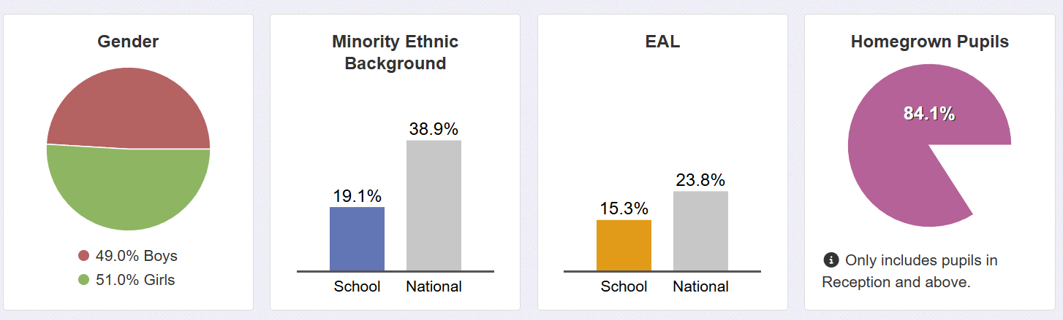

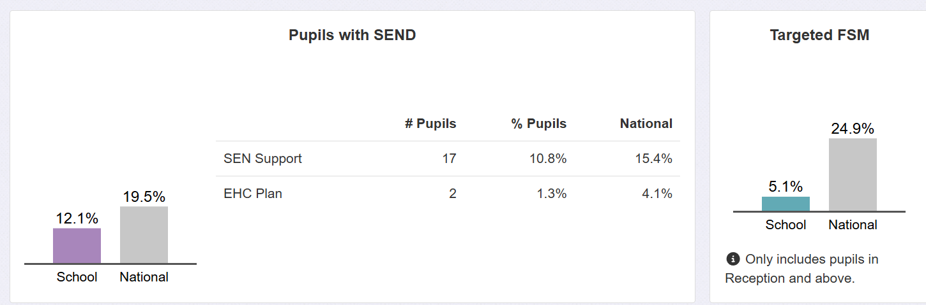

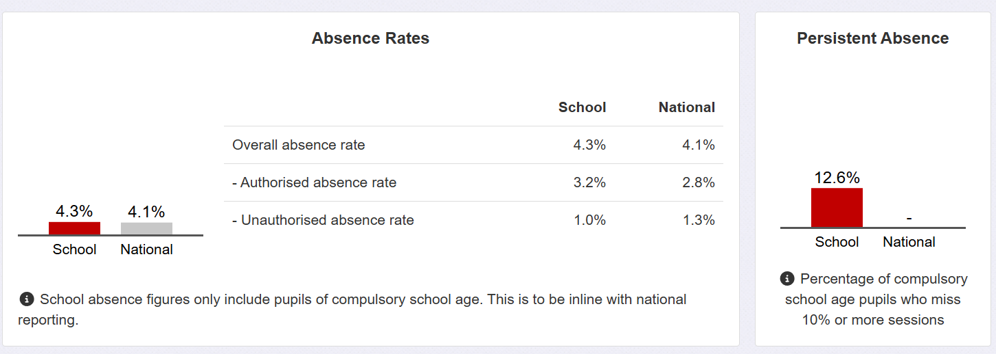

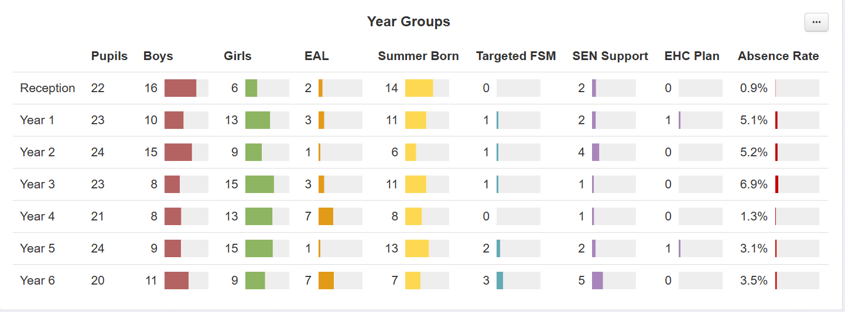
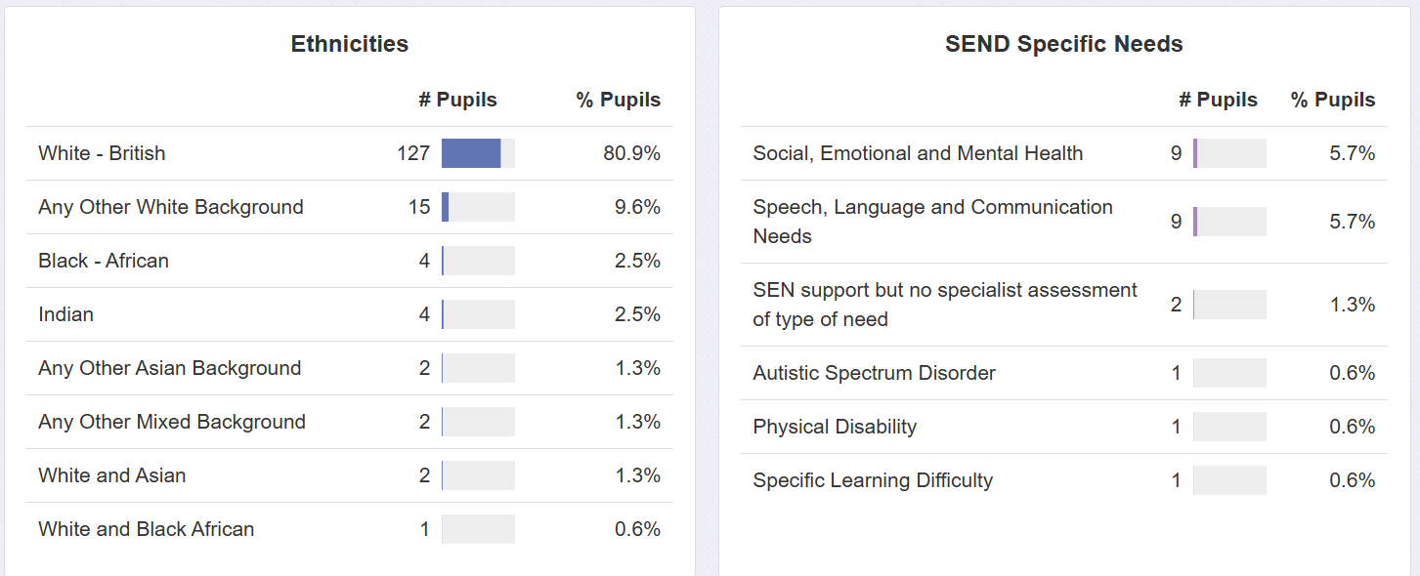

RESPONSE TO LAST INSPECTION
Area for improvement | Actions taken | Impact of actions
Strengthen the strategic focus of leaders and governors on the Catholic life and mission of the school and collective worship through systematic self-evaluation and analysis. | RE link Governor and Head Teacher have taken a more strategic approach in self -evaluation | More monitoring has taken place across all areas.  Feedback given to staff for staff to make improvements.
Provide more opportunities for all children to achieve a greater depth of understanding by presenting their learning in a variety of ways | - Using the RED scheme of work in all year groups | - There are more opportunities for pupils to present their learning in a variety of ways
Develop staff confidence and skills in planning, leading and evaluating collective worship for them to be able to support pupils to be independent leaders of prayer | - Training was led by Louise White in February 2024 organised by the Trust.  - P&L coordinator to organise specific training for our school staff – tbc | - The training gave an overview of what leading prayer and collective worship could look like, but staff would like more practical ideas, so P&L coordinator to organise specific training for our school.

TRAINING

Events attended by Pupils:
Chaplaincy Commissioning
Year 6 Leavers’ Mass
Chaplaincy Days with the DCET led by the Diocese
Catenian Public Speaking competitions led by the DCET Trust

In House Training

Date of training | For who | Led by | Focus
5th December 2023 | Teachers within DCET | Key staff in DCET ie Heads | Planning across year groups in DCET for Christmas and Revelation
6th February 2024 | Teachers within DCET | Key staff in DCET ie Heads | Planning across year groups in DCET for Lent
20th February 2024 | Teachers @St JT | Jon Schwartz | Catholic Social Teaching
12th March 2024 | Teachers within DCET | Key staff in DCET ie Heads | Planning across year groups in DCET for Holy Week and Easter
7th May 2024 | Teachers within DCET | Key staff in DCET ie Heads | Planning across year groups in DCET for Pentecost
21st May 2024 | Teachers within DCET | Key staff in DCET ie Heads | Planning across year groups in DCET for Sacraments
28th January 2025 | Teachers @ St JT | Teresa Harvey | Year of Hope – launching it and expectations
14th February 2025 | Teachers and RE link Governors across the Trust (INSET) | Louise White | Prayer life
25th February 2025 | Teachers @ St J&T | Teresa Harvey | Book scrutiny and standards
4th November 2025 | Teachers @ St J&T | Teresa Harvey | Opportunity to look at RE planning together as a staff

Member of Staff | Training
Teresa Harvey (started at St J & St T 2017): | Cross Phase Modular Course – June 2003  Aspiring Leaders Programme (At Previous school)  All RE Leads meetings led by the Diocese  Majority of Chaplaincy lead meetings led by the Diocese  All Head Teacher Conferences  All Senior Leader Retreats  Primary RE updates  Introduction to the Diocese for new heads, deputies or Assistant Heads  Partnership Briefings  Admissions training – 28.9.2023  DCET planning meetings for RE teaching and learning  DCET RE leads meetings  I have led RE link Governor meetings for the DCET  RED training  Helped with planning for RED for Year 3 & EYFS  CSI Inspector training
Jonathan Schwartz | Cross Phase Modular Course  RE leads meetings led by the Diocese  Primary RE updates  Partnership Briefings  DCET planning meetings for RE teaching and learning  DCET RE leads meetings  RED training led by the Diocese
Luke Justin | New to Catholic Education  DCET planning meetings for RE teaching and Learning  RED training led by the Diocese
Tara Bomani | New to Catholic Education  DCET planning meetings for RE teaching and learning  RED training led by the Diocese
Nicola Willmott | DCET planning meetings for RE teaching and learning  RED training led by the Diocese
Ruth Thompson | Helped with planning for RED for EYFS  RED Planning meetings  DCET planning meetings for RE teaching and Learning  RED training led by the Diocese
Anastazia Nurse | Chaplaincy Meetings led by the Diocese  RED training led by the Diocese

GRADE SUMMARY
Overall Effectiveness - | 2

Catholic Life and mission | 2 |  | Religious education | 2 |  | Collective worship | 2
CLM1 The extent to which pupils contribute to and benefit from the Catholic life and mission of the school | 2 |  | RE1 How well pupils achieve and enjoy their learning in religious education | 2 |  | CW1 How well pupils respond to and participate in the schools’ collective worship. | 2
CLM2 The quality of provision for the Catholic life and mission of the school | 2 |  | RE2 The quality of teaching, learning and assessment in religious education | 2 |  | CW2 The quality of collective worship provided by the school | 2
CLM3 How well leaders and governors promote, monitor, and evaluate the provision for the Catholic life and mission of the school | 2 |  | RE3 How well leaders and governors promote, monitor, and evaluate the provision for religious education | 2 |  | CW3 How well leaders and governors monitor and evaluate the provision for collective worship | 2

CATHOLIC LIFE AND MISSION | Overall Grade for CLM  2

CLM1 The extent to which pupils contribute to and benefit from the Catholic life and mission of the school | Grade  2

Strengths – what is the impact of the actions you have taken?
- Pupils enthusiastically embrace the many opportunities to participate in the Catholic life and mission of the school.
- Pupils demonstrate a strong sense of belonging to this welcoming, inclusive Catholic community with its rich cultural diversity and clear focus on globalisation.
- As a result of our well – defined values our pupils can demonstrate that they are aware of the values of the trust.
- Pupils are confident in knowing what each value means to them and how they can live the value in their everyday lives.
- Pupils are beginning to demonstrate to other pupils how to live out the values and parents are sharing how they are living out the values at home
- Pupils are alert to the needs of others, both within and beyond the school community, demonstrating an informed understanding of following Jesus’ example as expressed in the Gospels, how to act in the light of the Gospel values and Catholic Social Teaching in order to support others who are less fortunate. Pupil chaplains can articulate their purpose and can explain how their work reflects CST principles. This is evident in their participation in a wide range of charities such as donating to the local Food Bank, fundraising and collecting for CAFOD and other charity work, sometimes chosen by the children
- Pupils’ understanding of the importance of service is further deepened through contact with local CAFOD representatives.
- Pupils value the school’s chaplaincy provision which has a high profile across the school, including pupils from Years 4‐6. Pupils with support are taking the lead in whole school events such as leading Bible Alive sessions for the whole school, leading on a CAFOD club at break time; leading prayer opportunities for the whole school; leading fundraising; helping to prepare Masses etc. Our aim is to encourage the Chaplaincy team to become independent in this.
- Our pupils take ownership and demonstrate through living out of their own lives and teaching of the church through applying to be part of the Chaplaincy and Eco Teams.
- The pupils have opportunities to respond to Catholic Social teachings through the planning of their class reflections and responding by thinking of others.
- Our pupils show respect for others and their faiths through a planned provision that builds on previous knowledge and learning.
- Pupils in our school whose first language is not English are supported by our Assistant Head in delivering a language of the month. All children are encouraged to learn simple phrases in this language to use around school.
- Behaviour across the school is good on the whole and reflects the school’s clear focus on all its members displaying ‘being, ready, being respectful and being safe’. Consequently, pupils’ conduct and relationships with each other demonstrates respect across the school.
- Pupils value the opportunities the school provides for their personal support and development which enables them to be happy and confident individuals. This, alongside a child‐centred education in personal relationships (RSE) prepares them for the next stage of their physical, social, emotional and spiritual development.
- Summer of 2025 – staff have indicated in their curriculum maps, where they can ensure Catholic Social teaching is taught as part of the curriculum rather than separately.
- Catholic Social teaching is being embedded through AT3 RE learning but also through Bible Alive sessions for the whole school led by the Chaplaincy team.
- Our response to ‘chaplaincy for all’ / faith in action is a CAFOD club which pupils from EYFS to Year 4 can join. Presently, the adult chaplaincy leader works with Years 4,5 and 6 for 1 hour / week during class time on the diocesan Leaders in faith awards.

What could be improved?
- Enable all pupils to contribute in a planned and systematic way to the school’s evaluation of its Catholic and prayer life, and take a more active role in planning improvements to it;
- Articulate what ‘Chaplaincy for All’ looks like at St. Joseph’s and Teresa’s (in partnership with DCET working party). What does faith in action look like for ALL pupils – even if they are not in a club or committee? Do they realise that when they are contributing to a charity, they are exercising faith in action? – raise the profile of all pupils (and staff) as ‘global faith citizens’.
- Develop a bespoke model of the diocesan Leaders in Faith initiative for KS1 pupils.
- Build on the capacity of the chaplaincy team so that they grow in leadership and independence. Examples of activities include:
- monitoring prayer tables in classrooms with a very clear set of expectations. Can they set up and maintain WAGOLL? Can they feedback findings and next steps to staff in a professional manner – these skills will need to be explicitly taught.
- Develop independence through planning, promoting and leading regular lunchtime prayer sessions reflecting the Liturgical Year which all pupils and staff are welcome to attend eg. rosary club, stations of the cross, November remembrance, Advent reflections. Support will be needed to initiate this, with the provision of suitable, quality resources. Leaders and pupil chaplains should monitor the quality and impact of provision. Pupil attendees should be given the opportunity to reflect on the prayer experience.
- Pupils should actively contribute to planning the chaplaincy action plan and take a lead in evaluating the impact, and report to leaders and governors.
- Pupil chaplains could update the school community including governors, parents and parishioners with a standing item in the Headteacher newsletter / separate termly newsletter / page on website / parish newsletter / articles in the local newspaper etc.

CLM2 The quality of provision for the Catholic life and mission of the school | Grade  2

Strengths – what is the impact of the actions you have taken?
- The Trust’s mission statement permeates every aspect of school life.
- There is a strong sense of community, evident in the high quality of relationships and strong culture of welcome within this inclusive community. All staff promote good standards of behaviour and are excellent role models of mutual respect and forgiveness for pupils.
- The school environment clearly reflects its Catholic identity and ethos through our displays, the visibility and centrality of religious artefacts and sacred spaces in classes. These are concrete signs that the school’s vision and mission are ‘lived and breathed’ in the everyday life of the school.
- The school is highly effective in promoting high standards of behaviour that reflect Gospel values and developing positive relationships between all its members. Consequently, relationships between staff and staff and pupils are exemplary.
- Staff provide the highest levels of pastoral care for pupils with an explicit and concrete commitment to the most vulnerable provided by an experienced and highly committed SENCO and ELSA support. Leaders and governors are attentive to the pastoral needs of all members of staff, ensuring that their needs are understood and catered for.
- Personal and Social Education (PSE), and Relationship and Sex Education (RSE) are carefully planned to reflect Catholic teachings and principles and have fully involved staff, governors and parents in the process.
- There is a strong sense of community and commitment amongst staff, driven by the Senior Leadership team and team of governors who oversee this area.
- All staff are aware of their responsibilities in promoting Catholic education and supporting children on their faith journey. One INSET Day each year is set aside to support the teaching of RE or developing spirituality.
- PTFA organise a second hand uniform stall to support those who may need it.
- New families are welcomed to the school by pre-arranged visits before applying. Our reception children are welcomed to three visits in the summer before they start in the autumn for some stay and play visits as well as parents invited to a briefing meeting as to what to expect.
- All whole school masses take place in St Joseph and St Teresa’s Catholic Church, parents and parishioners are invited to attend to develop and share the faith with their pupils.
- We have ELSA support and PFSA support available to our more vulnerable pupils and families if they need it. Our staff meet regularly with parents to ensure they provide the best support for our pupils.
- There are leadership opportunities for our children. Year Six children apply for jobs at the beginning of the school year to support the pupils and staff throughout the school. Pupils in years 5-6 apply for the role of Chaplaincy and pupils from Reception – Year Six, apply for a role on the ECO council. They all take on different roles to ensure we provide the best support and opportunities for pupils across the school. Our Year 5/6 pupils apply to be peer mentors to support our younger pupils with play at break and lunchtimes.
Around the school are different icons to represent us as a Catholic school and displays in the corridor reflect all we do to develop and support the pupils’ faith.

CLM3 How well leaders and governors promote, monitor, and evaluate the provision for the Catholic life and mission of the school | Grade  2

Strengths – what is the impact of the actions you have taken?
- Leaders and Governors embrace and promote the Bishop’s vision for the diocese through active participation in diocesan initiatives and attendance at training and conferences.
- The school has been engaging parents to have an understanding of the school’s mission Parents value regular communication from school through the newsletters.
- Leaders and governors ensure that the whole curriculum contributes to pupils’ spiritual, moral, and vocational development.
- Professional development, focusing on the Catholic life of the school, occurs frequently and is engaging, well planned and effective. It is offered to all staff both through in‐house training and accessing training offered by the diocese. This is often done in collaboration with other Catholic partner schools. One INSET day is devoted explicitly to focusing on enhancing the school’s Catholic life and supporting all in their faith journey.
- Leaders and governors are highly ambitious for the school’s Catholic life and lead by example, providing challenge and support where necessary
- Resources are consciously and effectively targeted at those in greatest need (ELSA, Support for children with SEND)
- Policies and structures in place that provide levels of pastoral care for staff (Risk Assessments, Wellbeing meetings, Flexi Days, Flexible Working)
TH is a trained Catholic Schools Inspector.
What could be improved?
- In monitoring Catholic Life and Mission, staff and governors should focus specifically on key areas for improvement and revisit them 6 months later to ensure improvement and celebrate new strengths.

RELIGIOUS EDUCATION | Overall Grade for RE  2

RE1 How well pupils achieve and enjoy their learning in religious education | Grade  2

Strengths – what is the impact of the actions you have taken?
- Overall, pupils make good progress in relation to their starting points and capabilities across the key stages. The school’s open, inclusive culture has enabled all pupils to develop and grow. Pupils with special educational needs are making good progress due to effective planning on the part of teachers and support from teaching assistants.
- Pupils’ attitudes to all aspects of their learning in RE are positive and have a good impact on the progress they make. The excellent relationships grown by teachers create a happy and purposeful environment in which students enjoy their learning and are confident, keen learners who want to find out more.
- Majority of pupils enjoy their learning in RE and speak confidently about the progress they are making.
- As they progress through the school, they are developing an informed understanding of key religious concepts. The school’s strong Catholic ethos, prayer life and parish links play a major role in supporting pupils’ religious literacy. This is evident in their enthusiastic responses and involvement in assemblies and liturgies which demonstrate a high level of understanding of their class RE work.
- KS2 Pupils can use their knowledge and understanding of their learning in RE to reflect spiritually and ethically and on the importance of faith in action and Catholic Social Teaching (CST).
- Religious education plays an important part in developing children’s faith as well as making a valuable contribution to their spiritual and moral development.
- Pupils respond well to opportunities which extend their learning. They enjoy a variety of approaches such as role‐play, debate and hot‐seating and art activities and I wonder questions.
- Pupils take pride in their work and their learning and enjoy sharing their own questions and ideas.
- ‘I can’ statements are stuck in the children’s books at the beginning of each branch. The teachers are using these for assessment.

What could be improved?
- To develop the number of children working at greater depth, we need to identify individual children who are currently ARE and could be ‘Working at Greater Depth’ in a list for teachers. This would enable teachers to ensure that GD objectives are targeted from the outset of the lesson. Ensure that teachers are planning for greater depth children to be given work more quickly at Greater Depth – with teachers using the knowledge planners/Diocese resources. To ensure that the GD objectives are targeted from the outset of the lesson.
- To embed awareness and deepen understanding of Catholic Social Teaching principles in Key Stage 1.
- Continue to develop a cohesive approach to the language of Head (knowledge) Heart (discern) and Hand (action) across the school. Strengthen staff understanding to ensure a range of questioning linked to the new RED.

RE2 The quality of teaching, learning, and assessment in religious education | Grade  2

Strengths – what is the impact of the actions you have taken?
- Teachers are effective in planning high quality lessons which enable all pupils to make good progress in relation to their starting points.
- Teachers are alert to the needs of individuals in RE, using this to consolidate and extend pupils’ knowledge and understanding. As a result, teaching is consistently good.
- Teachers are growing in confidence in their subject knowledge.
- Overall, teachers employ a wide range of teaching strategies to engage and motivate their pupils and communicate high expectations to their pupils.
- All teachers routinely use recall of prior learning in order to start a new lesson. New little ‘Reflection books’ have been introduced from EYFS to Year 3 and effectively record activities which recall prior learning before start a new unit.
- Some teachers skilfully build on pupils’ contributions and encourage pupil empathy through ‘I wonder’ and creative, investigating thought rather than merely recall of knowledge.
- Teachers set clear objectives and use ongoing assessment within lessons to address misconceptions.
- Clear assessments are in place across the school, with each unit of work assessed and levelled.
- Moderation has taken place across the Trust.
- Staff are demonstrating ongoing commitment, open mindedness and preparedness for the implementation of the RED, with all attending the regular diocesan ‘before you begin’ online sessions.

What could be improved?
- Move away from teaching RE in an afternoon block into smaller chunks to get the best learning from the pupils.
- To ensure books reflect the quality and quantity of work provided within the lesson.
- Moderation of learning to take place regularly.
- To ensure that teachers are planning for greater depth children to be given work more quickly at Greater Depth – with teachers using the knowledge planners/Diocese resources. To ensure that the GD objectives are targeted from the outset of the lesson.

RE3 How well leaders and governors promote, monitor, and evaluate the provision for religious education | Grade  2

Strengths – what is the impact of the actions you have taken?
- Leaders and governors ensure that the religious education curriculum meets the requirements of the Bishops’ Conference in every respect and in each key stage.
- All Year Groups are using the new RED scheme as recommended by the Diocese.
- Governors and leaders value the training provided by the diocese and are fully up to date with all aspects of this. Appointments to reserved posts are made in accordance with diocesan policy and teachers new to Catholic education attend diocesan training.
- Thorough and systematic monitoring procedures are in place where staff carry out learning walks, book scrutiny, pupil interviews and lesson observations, reporting to the RE link Governor. These are formally reported at Full Governing Body Meetings, ensuring that all governors are aware of strengths and weaknesses in RE, Catholic and prayer life. In addition, some governors attend class assemblies, liturgies and whole school and class Masses.
- RE data is gathered and scrutinised on a regular basis to identify areas of strength and areas for development and shared with governors.
- RE Leader has a clear vision for religious education and teachers are supported in the knowledge they need to teach.
- School has good links with agencies, such as: CAFOD, and the local food bank.
- We are developing our approach to teaching other Faiths in line with the RED.
What could be improved?
- Enrichment activities for other Faiths – linked to new curriculum coverage. Other Faiths to be linked to the children in our school who are of other faiths, in line with the ‘Encounter and Dialogue’ Branch 6 guidance.
- In monitoring RE teaching and learning, staff and governors should focus specifically on key areas for improvement and revisit them 6 months later to ensure improvement and celebrate new strengths.
- To develop assessment effectively using the new RED scheme and to be guided by the Diocese.

COLLECTIVE WORSHIP | Overall Grade for CW  2

CW1 How well pupils participate in and respond to the school’s collective worship | Grade  2

Strengths – what is the impact of the actions you have taken?
- Every pupil, regardless of their faith background, feels welcome to participate fully in the school’s rich prayer life, which takes place during the day.
- The school provides a wide range of prayerful experiences; majority of pupils show attentiveness; they respond to prayer and engage in communal singing.
- There is a hymn/music plan for Masses across the year; this ensures that the children are exposed to a wide range of hymns that link to the liturgical season, and/or feast day. This embedding of music ensures that pupils can engage with the spiritual aspect of prayer through music.
- Pupils across the key stages demonstrate high levels of interest and enjoyment in the school’s prayer life.
- Pupils engage in worship in both school and church. There are high levels of participation in seasonal celebrations such as reflections on the Stations of the Cross in Lent.
- The profile of chaplaincy has been raised within the school, with pupils from Year 4 to Year 6 supported by the Chaplaincy leader taking the lead in whole school prayer events, whole school and class assemblies and involvement with the chaplaincy leader in planning some Masses.
- The chaplaincy team uses a variety of approaches to prayer which include scripture, religious artefacts, liturgical music.
- Pupils are familiar with the format of the pupil-led four-part Celebration of the Word.
- Behaviour is generally good, where pupils are respectful, engaged and can be silent
- Pupils are familiar with some of the signs, actions and rituals used in Catholic prayer services eg. making the sign of the cross, greeting the Gospel with ‘God by in my head…’ They join in with traditional prayer such as the Our Father or Hail Mary.
What could be improved?
- Strengthen the ‘respond’ aspect of pupil led reflections
- All children to evaluate their own Celebration of the Word, through what they liked /enjoyed and ideas for future celebrations of the word.

CW2 The quality of collective worship provided by the school | Grade  2

Strengths – what is the impact of the actions you have taken?
- Prayer is the heartbeat of every school celebration and is central to its life.
- Children have regular opportunities to participate in Mass, including whole school Masses at the beginning and end of every school year, Holy Days of Obligation.
- Class Liturgies and / or masses depending on the age take place during the academic year and parents are invited.
- Members of staff join the parish for the children’s First Holy Communion Mass.
- Displays in and around the school are supportive of the school’s Catholic life. Prayers are displayed in the classroom, with a prayer table acting as a focal point for prayer and reflection in the classrooms.
- School Mass is open to parents and members of the parish enjoy sharing Mass with the children and comment this and take place in the church.

What could be improved?
- Build a bank of respond and mission activities relevant to the pupils’ age.

CW3 How well leaders and governors promote, monitor, and evaluate the provision for collective worship | Grade  2

Strengths – what is the impact of the actions you have taken?
- Leaders and governors have continued to build on the school’s prayerful community and supports important prayer opportunities within the school community such as supporting First Holy Communion the Diocesan Education Mass and the Year 6 Leavers’ Mass.
- Worship is prioritised in the event calendar, and a detail liturgical rota is in place with all teachers leading liturgical prayer and support is provided.
- Children are increasing their independence and confidence across the school in planning and delivering prayer.
- Holy Days are marked, and House Saints’ Days are celebrated.
- Sacrament of Reconciliation is planned in for Ks2 children who have made their first holy communion during Advent and Lent.
What could be improved?
- Governors ensuring that the cycle of monitoring is embedded and maintained year on year. Governors to follow-up on actions from the previous visit to ensure that monitoring is forensic.
- Prioritise staff training in order to develop the breadth and range of prayer experiences in the school eg. Lectio or Visio Divina, the Examen, Litany prayers etc. The Annual Plan of Prayer Provision and Prayer Progression documents should be completed to reflect this range of prayer opportunities.

PUPIL AND STAFF INFORMATION October 2026
Year Group or Class | No. of pupils | Number of Catholic pupils | Number of FSM eligible  (% in brackets) | Number of SEND pupils (incl. EHCPs) | Number of EHCP pupils | Number of Significant ethnic groups  (i.e. >5% of cohort) | Number of EAL
Foundation Stage | 22 | 6 | 0 | 2 | 2 |  | 2
Year One | 23 | 5 | 1 | 3 |  |  | 3
Year Two | 24 | 7 | 1 | 4 |  |  | 1
Year Three | 23 | 7 | 1 | 1 |  |  | 3
Year Four | 21 | 6 | 0 | 1 |  |  | 7
Year Five | 24 | 6 | 2 | 3 | 1 |  | 1
Year Six | 20 | 10 | 3 | 5 |  |  | 7
Total | 157 | 47  29.9% | 8  5.1% | 19  12.1% | 3  1.9% |  | 24  15.3%
Compared to national averages
Taken from ASP 2025 Data
* Data taken from Catholic Education Service Digest of 2024 Census Data for Schools and Colleges in England

Published Admission Number (PAN) of Pupils: | 22 |  | Percentage of pupils from other religions: | 0
Percentage of pupils who are baptised Catholics: | 29.9% |  | Percentage of pupils who are non-religious: | 0
Percentage of pupils from other Christian denominations:
Religion Data

Staffing Primary – give details of all teaching staff; Secondary and sixth form college – give details of staff teaching religious education
Name | Responsibility | RE specialist?  (Y/N) | Experience | Current service | FTE | CCRS or equivalent  (Y/N)
Teresa Harvey | Head Teacher  Catholic Life and Mission & Prayer Life lead  Teach 3 afternoons | N | 25 years | 9 years | Full time | Y – equivalent
Jonathan Schwartz | Assistant Head  Year 5 /6 Teacher  RE teaching and Learning Lead | N |  | 7 Years | Full time | Y – equivalent
Luke Justin | Year 4/5 teacher | N | 7 years | 7 years | Full time | N
Tara Bomani | Year 2/3 Teacher | N | 12 years | 8 years | Part Time | N
Tiffany Garstang | Year 2/3 Teacher | N |  |  | Part time | N
Nicola Willmott | Year 1/2 Teacher | N | 10 years | 10 years | Part Time | N
Jess Burgess | Year 1/2 Teacher for half a day  SENCO for a day and a half | N | 13 years | 3 years | Part Time | N
Ruth Thompson | Early Years Lead  Year R/1 Teacher | N | 22 years | 11 years | Part time | N
Anna Jones | Year R/1 Teacher | N |  | 2 terms | Part Time | N
KEY
Experience – years in teaching; Current service – years in this school; FTE – where 1.0 represents full-time
Senior Leaders
Name | Responsibility | Experience | Current service | FTE | CCRS or equivalent  (Y/N)
Teresa Harvey | Head Teacher  Catholic Life and Mission & Prayer Life lead  Teach 3 afternoons | N | 22 years | 8 years | Full time
Jonathan Schwartz | Assistant Head  Year 5 /6 Teacher  RE teaching and Learning Lead | N |  | 7 Years | Full time

CURRICULUM INFORMATION
Please indicate the amount of the taught week allocated to the teaching of religious education
Year Group or Class | Total curriculum time (in minutes) | Total RE curriculum time (in minutes) | % RE curriculum time (to one decimal place)
All year groups | 320 minutes | 150 minutes | 46.9%

Please indicate the programme(s) of study followed (Sixth form providers, include A-level Religious Studies and Core RE)
Key Stage | Details of programme(s) of study followed
EYFS | New RED
KS 1 | New RED
Year 3 and Year 4` | New RED
Year 5 and Year 6 | New RED

Subject | Last year | This year
Religious education | £1,446 | £2,000
English | £1,964 | £2,342
Maths | £1,218 | £1,978

