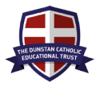
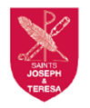
Chaplaincy Newsletter
Term 1 2026
Who are the chaplaincy team?
- Edie, Romilly, Danyil, Evan Florrie T, Marianna, Julia, Aine, Bea S, Amber, James G, Bea N, Joseph, Erika, Lily W, Veronica and Ebony
- Mrs Nurse and Mrs Thompson

“A chaplain is someone who works with an adult to support the school community to worship God, celebrate our faith and help others in need” Evan

“The chaplaincy team help to organise and share the opportunities for all the school.” Danyil

“We are going to support the whole school become chaplains and do all the things in Bishop Bosco’s vision” Bea S
We are looking forward to…
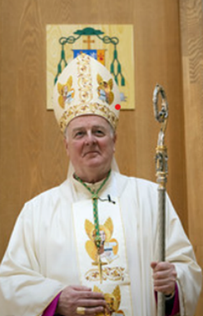
“This is Bishop Bosco.” “We are going to help his mission by being in chaplaincy” James

“ I would like to be involved in collecting for charity and supporting our local community. I feel
that I can help to support people who don’t have as much we do.” Romilly

“I think I will be good at helping share Gods message through bible alive assemblies. I’m looking
forward to acting to show the rest of the school a message and teach people the bible” Erika

“I am looking forward to praying in classes in school. I would like to help write new prayers and help the younger pupils with know how important prayer is for getting closer to God.” Aine

"I am looking forward to helping others in our parish community." Bea N

" I want to fundraise for Mary's Meals." Ebony

" It is important to look after the world and show Stewardship." Velina
"I am looking forward to going into care homes." Julia

"I am keen to help the younger children to learn about their faith." Florrie

" I want to have pop up prayer spaces and sell flapjacks." Danyil

"I am looking forward to going outside our school and joining the wider community." Bea S

"We are going to raise money for CAFOD." Edie

Bible Alive
- This term we have completed 2 Bible Alive assemblies.
The first was based on St Therese of Lesieux. She said - Remember that nothing is small in the eyes of God. Do all that you do with love. We told the school about her life and how she reminds us to do everything we can with love.
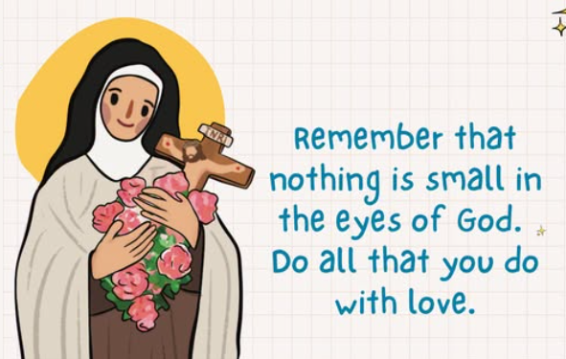

Florrie T- This is like our weekly missions- we try to do little things that make a difference to us and our friends.

- The second Bible Alive helped the school to explore the rosary before we said a decade together.

I liked sitting in a circle so we were close to Mary. – Aneirin

We lit a candle of each decade of the Rosary.- Lowen

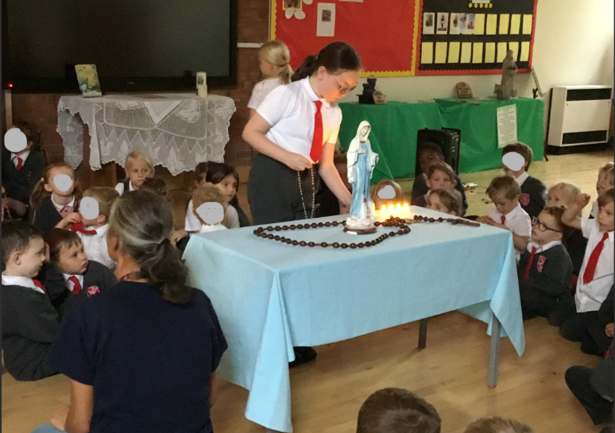

Mary is Jesus’s mummy in Heaven- Logan

It felt good to help the school pray with Mary – Ebony

Interactive prayer spaces
Each week we listen to the message from the Gospel as a whole school. The chaplaincy team help explain what this means and how we can put the Gospel into action. The chaplaincy team help Mrs Thompson to set a weekly mission and ask the school to show when they have completed the mission the display. Our Mission station is in the middle of our school so that it can be used by all the classes. Here is an example:
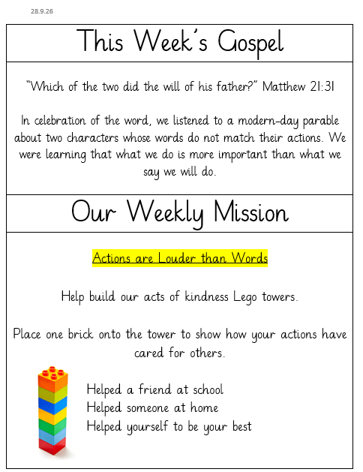
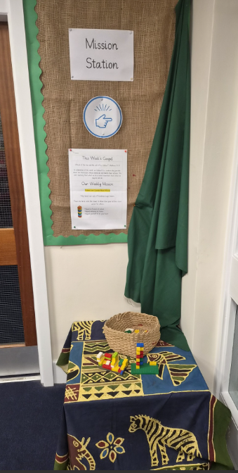

Footsteps in Faith
Each term every year group is working on a set of skills and knowledge in addition to their RE lessons. As we build on our understanding term by term and year and we are working towards our Footsteps in Faith Awards.

Every class has a display board to celebrate our success towards the awards. On the board we also collect examples of Catholic Social Teaching (CST) and our school values being lived by pupils. Here are just a few examples
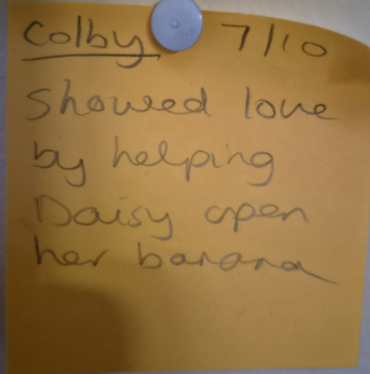
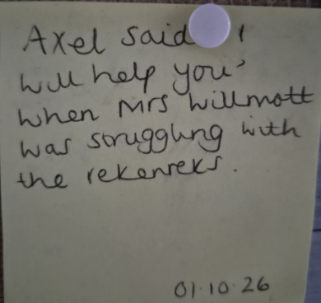
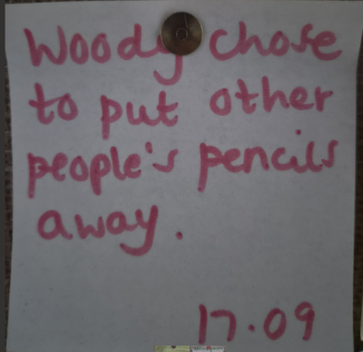
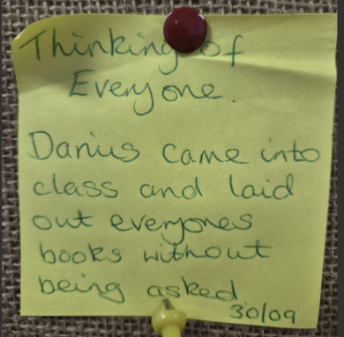

These awards and displays remind us to keep Christ at the centre of our daily actions and help us make CST and the school values a natural part of our lives as we grow.
Supporting Mass
The Chaplaincy team wrote some really thoughtful prayers of intercession for the school Mass on 14.10.26.
Evan – I liked it when we chose the prayers for Mass. It helped me think about why we pray for other people.
Fundraising
Harvest Festival Friday 2nd October
As part of our harvest celebrations, we have collected food to take to the local food bank.
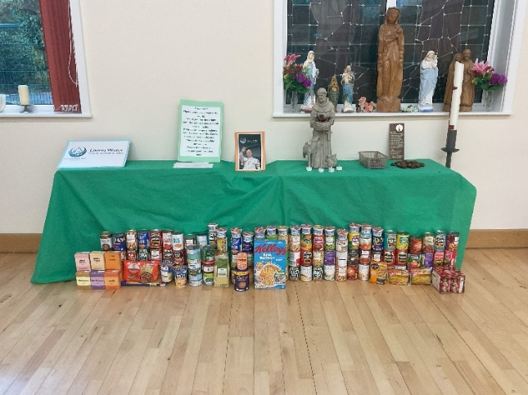

Porridge Party 9th October
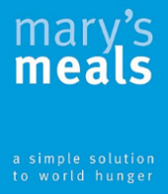
The chaplaincy team have supported the charity Mary’s Meals. Mary’s Meals provides one good meal every school day for hungry children living in 16 of the world’s poorest countries. The promise of this attracts children to the classroom, where they can gain an education and grow up well-nourished and well educated to become the men and women who will lift their communities out of poverty. We raised £81 by selling flapjacks that some of the chaplaincy team made in school.


Class Fundraising

Our chaplaincy team has asked each class to think of ways to fundraise for charity. All the classes are supporting CAFOD and have also chosen a second charity to fundraise for. Here is an example from Nightingale Class

