Thank you to all the children that gave excellent ideas to our school council.
We have looked through them all and picked out some of the ones we think are doable

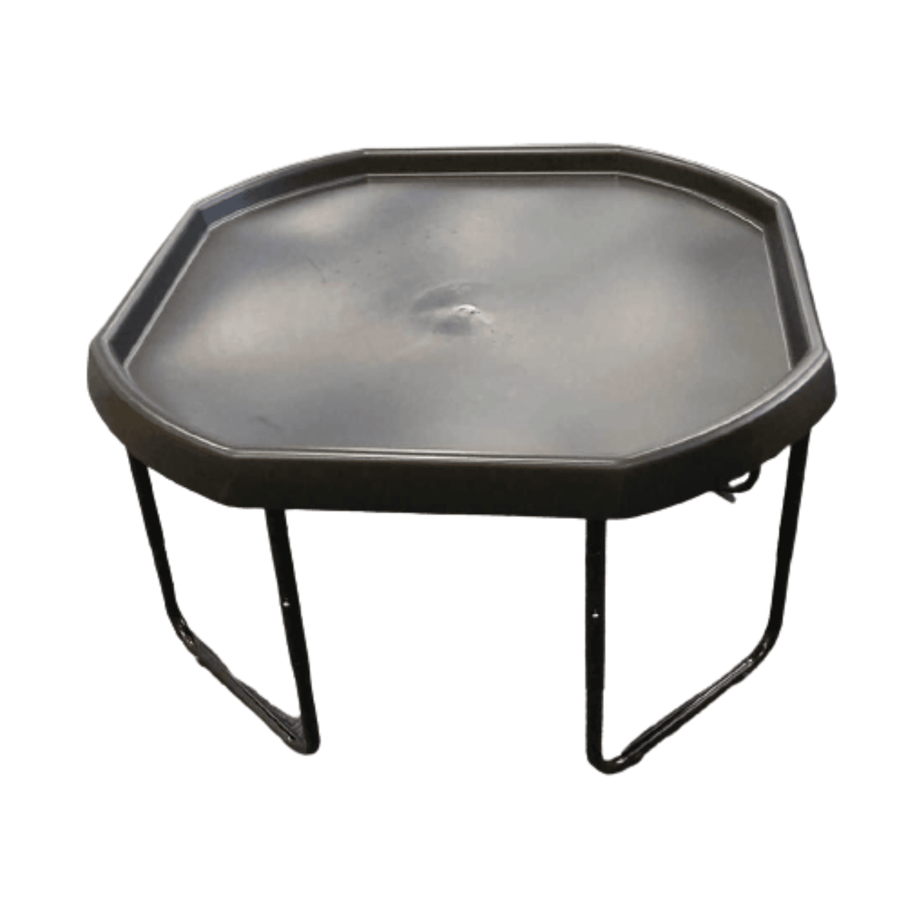
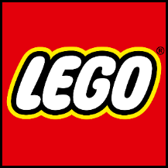
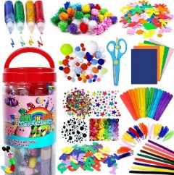
- Tuff trays for lunchtime arts and crafts and lego.

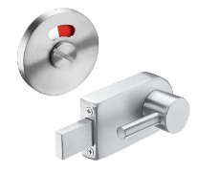
- Checking and adding new locks to the boys’ toilets.


- Children putting something in the school newsletter each week.

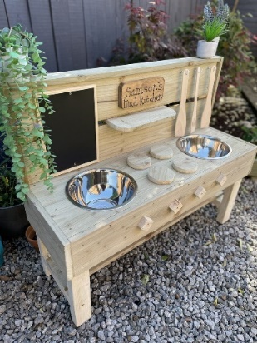
- Designated mud kitchen/role play area

- Achievement board (for achievements outside of school)
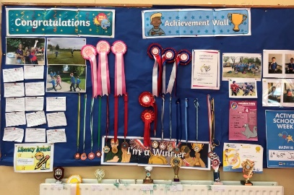
- Tennis net for play ground


